**Link to check point1:** [**http://77161488-aid.omobosoftwareinterface.com**](http://77161488-aid.omobosoftwareinterface.com)

**You must register to access the product page and user page.**

**Link to checkpoint2:** [**http://aid.omobosoftwareinterface.com**](http://aid.omobosoftwareinterface.com)

**Admin user log in:** [**admin@yahoo.com**](mailto:admin@yahoo.com)

**Admin password: admin123**

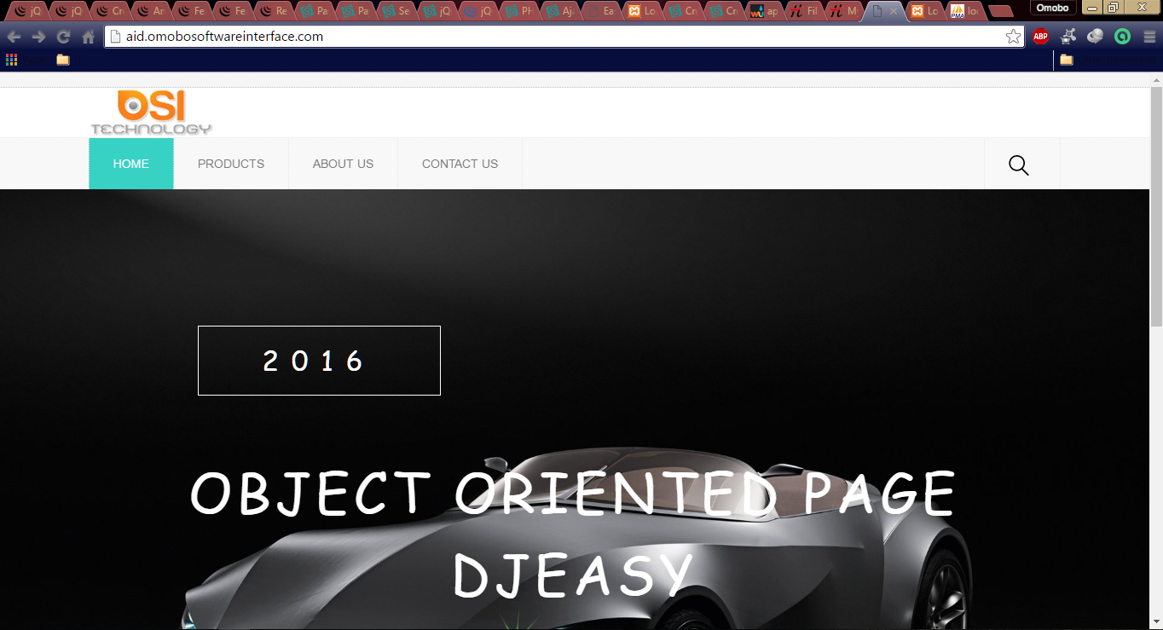

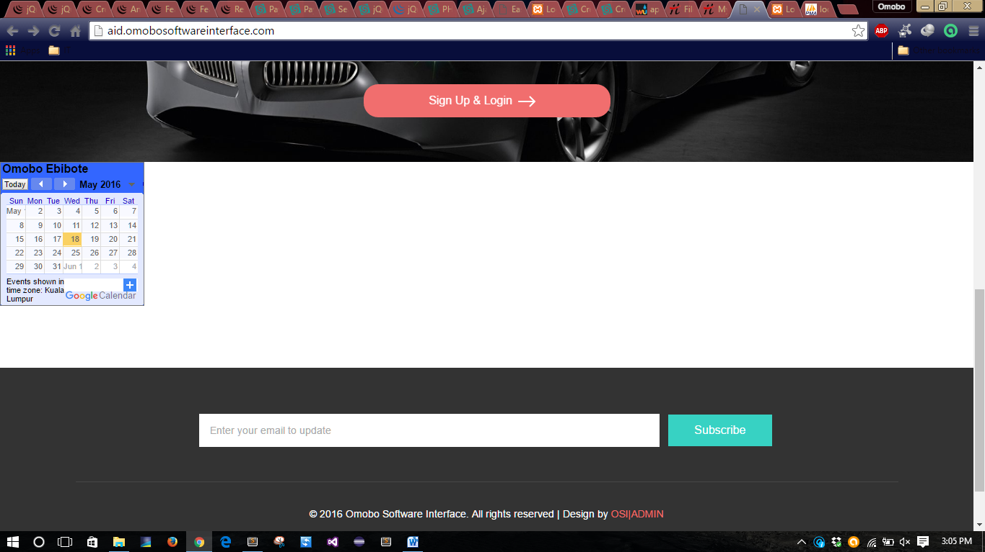

2

3

4

2. The link to the log in page

3. Google calendar API generated using my google API key

4. link to the admin log in page

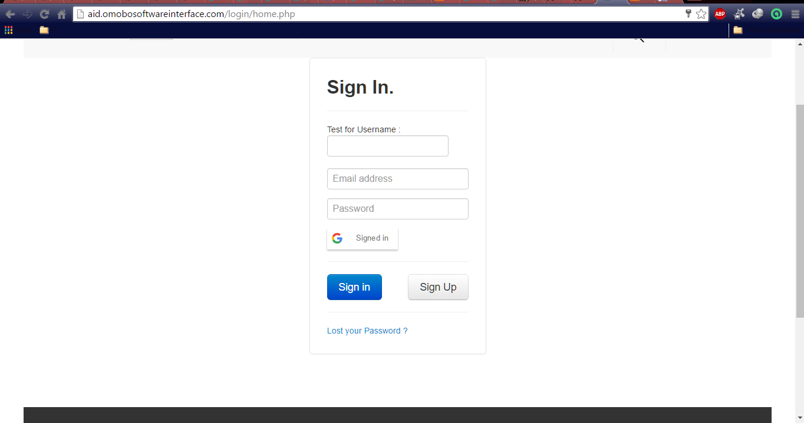

Sign in / Sign up page and also a google sign in button for google account holders

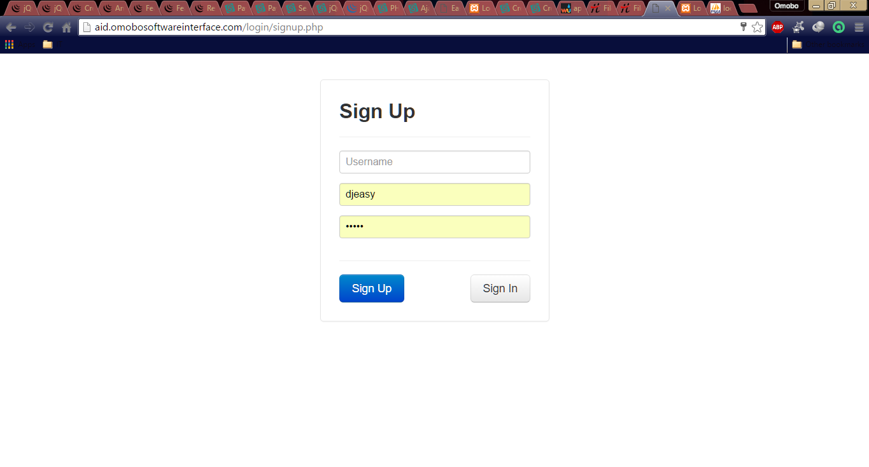

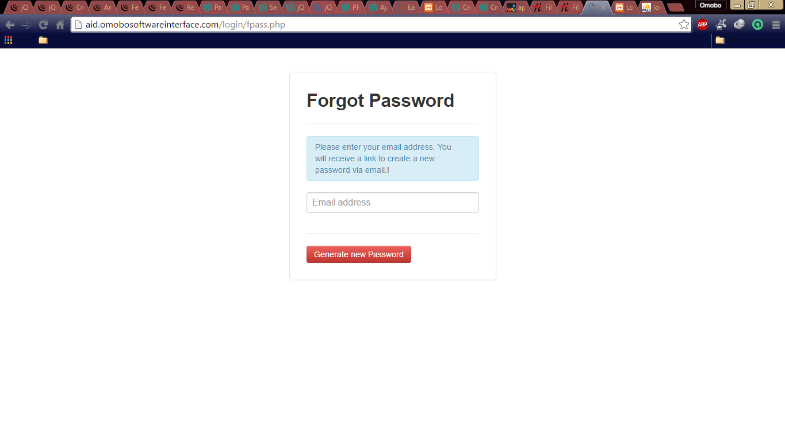

Users can generate a new password in case they forgot their password which is very common to every internet users, when you insert your email and click on the generate password button an email will be send to the email you registered with for you to create a new password.

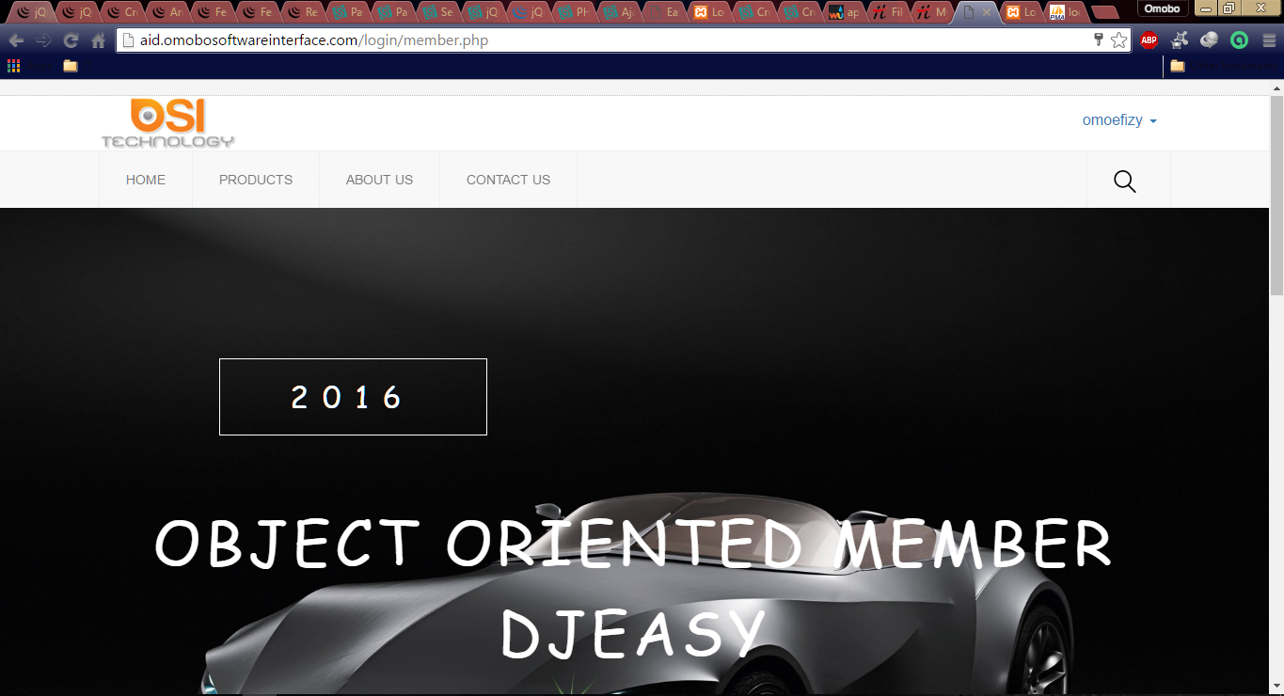

5

5. Once a user is signed in the user name would be displayed at the top right corner.

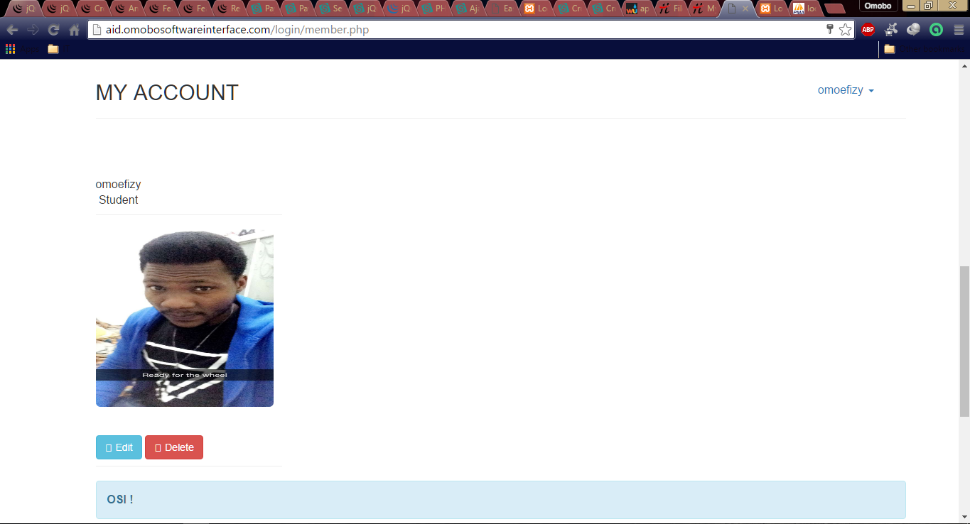

6

6. This is a user page where a user can edit and delete their account. Once the user delete their account they will automatically logout and redirected to the sign up page.

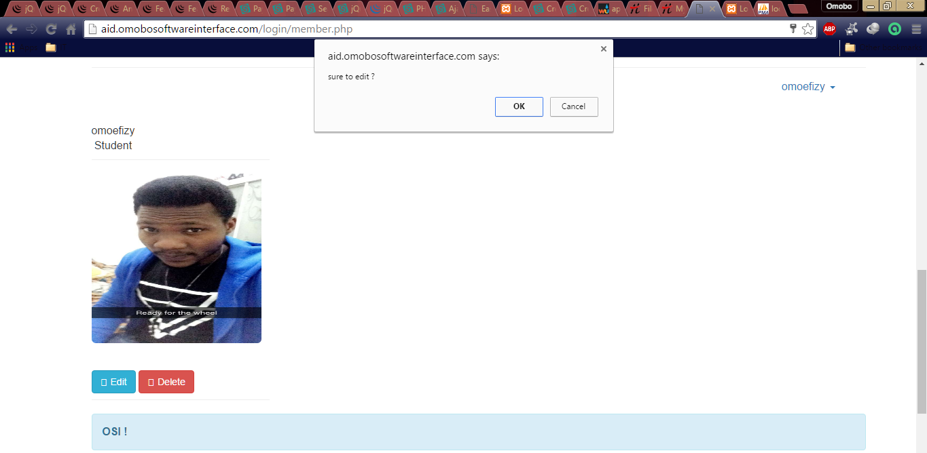

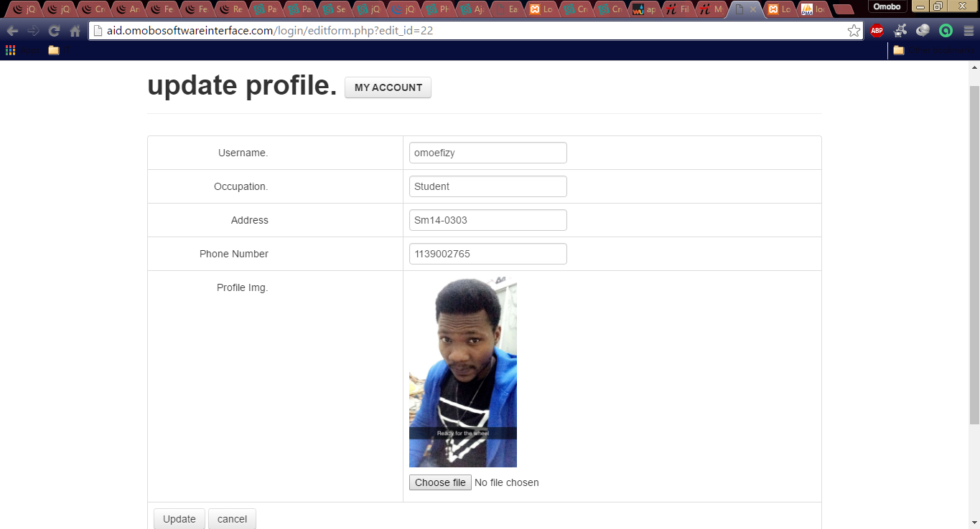

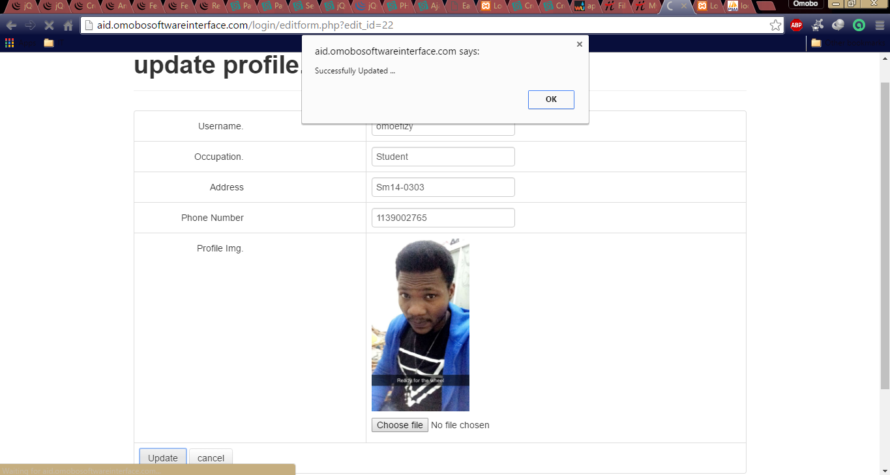

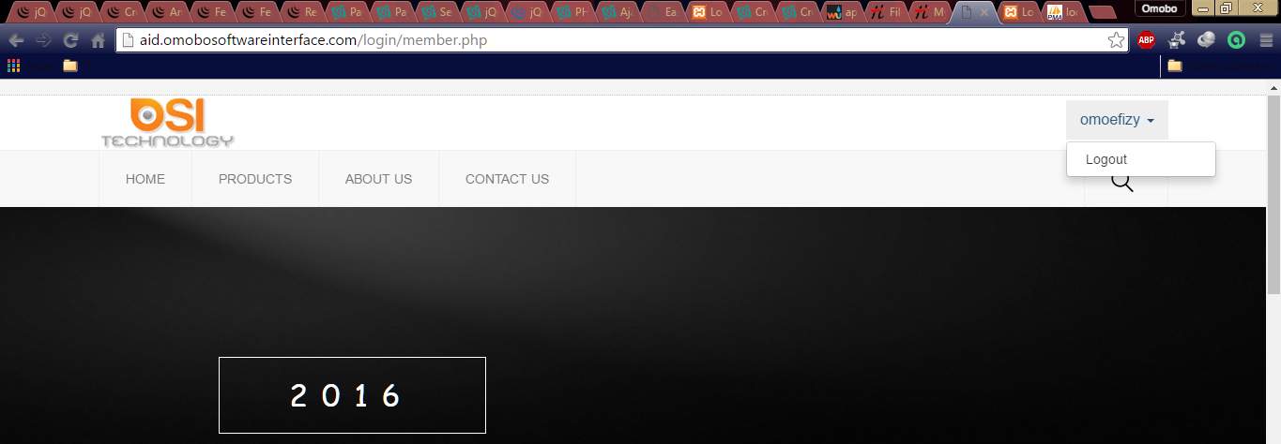

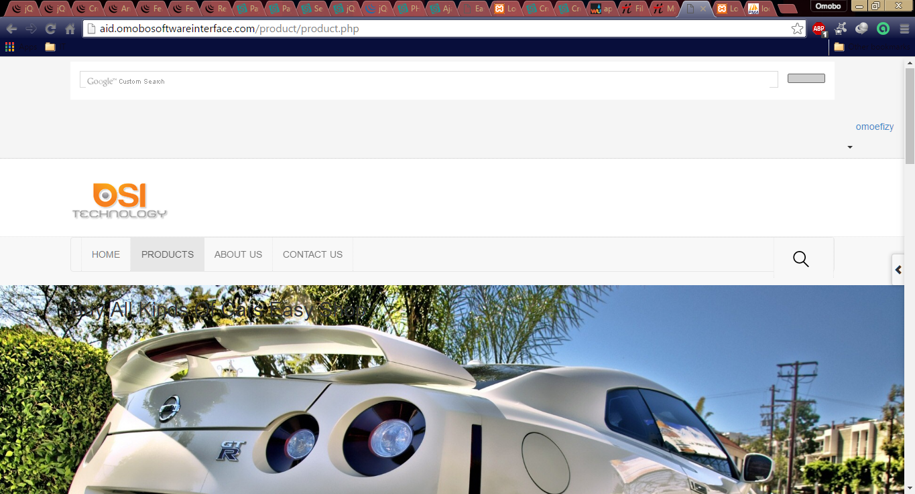

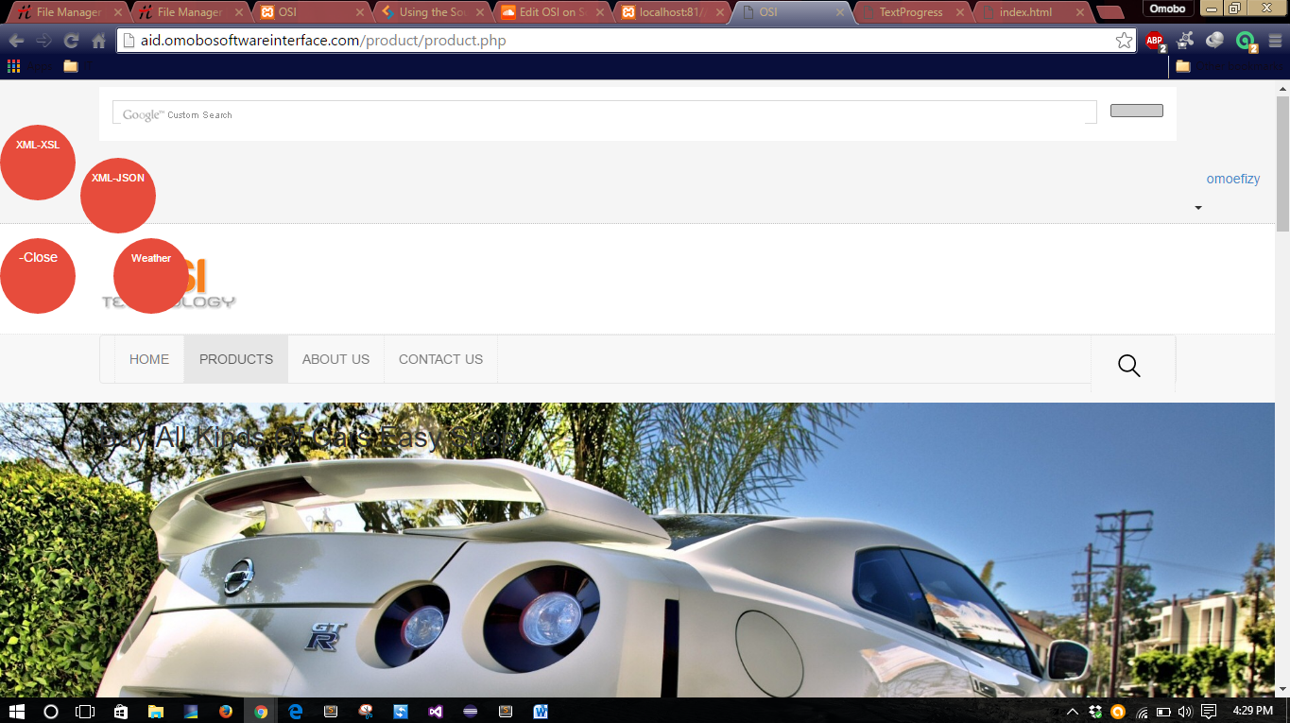

8

7

7. This a JQuery plugin arc menu that shows link to the XML-JSON file that’s extracted from database also the auto generated XML file using PHP and been formatted using XSL and also the weather underground

